**SOFTWARE REQUIREMENTS SPECIFICATION**

**FOR**

**AIRLINE FLIGHT BOOKING SYSTEM**

## Introduction

### Purpose

This SRS document presents a detailed description of the Airline Flight Booking system, version 1.0. It represents the client requirements analysis that defines the functional and non-functional requirements of the airline website and its different functionalities. It defines the abilities, reactions from stimuli, guidelines, and limitations of the system. This document will be complete in its scope of the system and the functions required. The system provides a solution to allow the user to search for flights satisfying the user criteria, to reserve seats, to manage the user account, and to book a flight.

**Document Conventions**

The document follows the IEEE format standard (IEEE Std. 830 – 1998).

### Intended Audience and Reading Suggestions

The intended audiences of this document are Dr. Chen, who is the client, software engineers, the spring 2009 CS5391 software engineering class and for anyone who has interest in software engineering.

### Project Scope

The airline booking website is an application stored in the user server. The purpose of the website is to resolve the client to allow website users to perform tasks related to booking an airline flight. Non-member users are only allowed to search for available flights; nonmember users are required to create an account in order to reserve a seat or to book a flight. Member users have the right to search for available flights, to reserve a seat, to book a flight, cancel a flight and to edit their member information. Member users are required to login into their account prior to flight booking.

## Overall Description

### Product Perspective

This project represents the initial version of the Airline Booking system. All requirements listed herein describe a self-contained system. At a high level, this project will allow a user to book flights, check flights, do account maintenance, and query flight information. The goal is to allow customers greater and easier access to the airline’s booking system, twenty four hours a day.

### Product Features

We can subdivide the project into 7 main features. Details of each of the following functions can be found in Section 3.

#### Login

**Description:** This function allows a registered user to login his account using his

frequent flyer number with the airline and password. If a user is not registered, the website shall allow the user to enroll first. The system will check both the frequent flight number and password, when a user attempts to login.

*Rationale*: This provides security to the system by authenticating each member and provides confidence to the consumer that his/her personal information is secure.

#### Enrollment

**Description:** This function allows unregistered user to enroll and to create a new

account with the website. In order to create a new account, the user has to provide required information such as first name, last name, email address and password. Other optional information, such as phone number, credit card information and mailing address, can be provided during the registration process.

The system checks if all required data are provided and then will prompt the user to enter additional information, if required. After all required information is provided, the system auto-generates a unique frequent flyer number that the user must use as username for future authentications. The system shall auto-generate this number in less than five seconds.

|  |  |
| --- | --- |
| *Rationale*: A user who wishes to purchase flights and use advanced features, must be logged in. However, without enrollment, a user can never be a member. This section offers all users a chance to become a member.    **Book Flights**  **Description:** The user can use the *Book Flights* function to purchase seats for an airplane flight. The system shall present the user with information on all current flights. The user may then select a pair (departure and return) of flights on which to purchase seats. The user can indicate the number of seats and placement of such. Finally, the system shall guide the user completely through the checkout process.    *Rationale*: The heart of the business is selling seats on flights. This section provides the primary source of system transactions.    **Reserve Seats**  **Description:** The user can use the *Reserve Seat* function to reserve seats for an | |
|  | airplane flight. The seats to be reserved are initially found through the user’s previous bookings. These bookings were previously completed through the *Book Flight* function (SEE 2.2.3).  The system shall display available seats for the departing and returning flights booked by the user. The user selects seats from each flight, where the number of selected seats from each flight is the number that the user booked on that particular flight. Once the flight seats are selected, the user confirms the seat selection. |
| *Rationale*:    **Flight Status** | Customers prefer to know where their seats are located. Further, they prefer to pick out particular seats – closer to the front, window seat, aisle seat, etc.    From that point, the seats are removed from available/unreserved seats and the user’s booking is linked to those particular seats. If the user fails to reserve a seat prior to flight takeoff, the user is randomly assigned a seat from available seats a 30 minutes prior to initial takeoff time. This function is offered immediately after booking the user can wait and use the function to book seats anytime after up until 30 minutes prior their flight |
| **Description:** This section shall allow the user – whether enrolled or not – to view flight information that matches input criteria. The user will provide:   1. A flight number and Date OR 2. Departing/Arriving Cities and Date. | |

The system will display matching flight information including the following fields:

|  |  |
| --- | --- |
|  | * Flight Number * Departure City * Arrival City * Status (one of the following) o In Flight o At the Gate o Delayed o On Time |
| *Rationale*: | Users will want to query the system to find flight information, even if they’re not at an airport (e.g., on their mobile phone). By making this information available through the web site, we can provide an extra service to the customer and increase our company’s value. |

#### Flight Schedules

**Description:** This section of the system shall allow a user to query flight schedules

based upon simple input criteria. The user will provide departure and arrival cities, and a departure/return date. If any flights match the criteria, the system will display the following information:

* Flight Number
* Departing City & Date/Time
* Arriving City & Date/Time
* Number of Available Seats

The system shall define a “matching” flight as one that uses the departure/arrival cities at a flight time greater or equal to the time provided by the user. Otherwise, the system shall alert the user that no matching flights can be found.

*Rationale*: A customer will want to book flights based on his/her travel plans. This section provides the user a choice of available flights from which to pick.

#### My Account

**Description:** This section gives the user the power to view, save, edit or delete the information stored in his/her account. The user can check his/her accumulated points, look at the status of a flight that was booked, cancel a flight that was already booked (optional) and change his/her address, phone number, email or password. This feature is not available for non-registered user.

*Rationale*: A customer’s information changes from time to time. Giving the users a way to modify their account information allows the business to have current & updated information.

#### Logout

|  |  |
| --- | --- |
| Description: | The *Logout* section provides a way for the user to securely log out of the system. This process will save all user operations when he/she exits the system. If a user wishes to continue accessing the website, he/she must log-in again to access user features. |
| *Rationale*: | Customers often use shared computers. Providing a way to clear state and log-out gives our customers confidence that nobody else will use their flight-booking session. |

### User Classes and Characteristics

The main actors in the system are (1) the user, (2) a flight and (3) a Flight Seat. The user will select a flight and book seats on the flight. They will then reserve specific seats on that flight. Brief descriptions of these classes follow:

* User o Has properties like Name, Address, Age o Associated with Flight Miles accumulated and Credit Card information.
* Flight o Has properties like Departing/Arriving City, Departure/Arrival dates and times, Miles, and an identifying Flight Number.
* Flight Seat o Has properties of identifying seat number, reserved and flight number o Associated to Flight by flight number

.

Our user may be associated with multiple flights, and many users may be associated with any particular flight. Thus, a many-to-many relationship exists through the act of booking flights.

Flights are associated to many Flight Seats. Each Flight Seat is only attached to one Flight. So, this is a one-to-many relationship

The flight is but an object to be acted upon, so careful emphasis should be placed on satisfying the user in his/her booking experience. The user is our primary customer.

## System Features

This section provides detailed requirements for the website design, including functional requirements.

### General Requirements

#### Login

|  |  |  |  |
| --- | --- | --- | --- |
| **Description and Priority:** | | | This function allows a registered user to login his account using his frequent flyer number with the airline and password. If a user is not registered, the website should allow the user to enroll first. The system will check both the frequent flight number and password, when a user attempts to login.  In most case, the frequent flight number is convenient for both the user and system performance. The user easily memorizes his or her flight numbers but not a dull string. For the system, when provided the flight number, flight information will be delivered at the same time. Therefore, such operation reduces the second query chance.  Theoretically, more than one record can retrieve by user’s frequent flight number and password. Two or more users may have chosen the same password and same flight number. The way to break a tie is that system will go further to ask user’s email confirmation to identify. |
|  |  |  |
| **Inputs:** |  |  | Frequent flyer number and password |
| **Source:** |  |  | All inputs are provided by user. |
| **Outputs:** |  |  | Indication that user is logged in to the system. |
| **Destination:** | |  | The outputs are displayed on the screen as well as stored in the system. |
| **Requires:** | |  | The user provides login information including frequent flyer number and password. |
| **Pre-Conditions:** | |  | User is not logged in to system. User has previously enrolled in system. |
| **Post-Conditions:** | |  | User is logged in to system, OR user is not logged in because he/she entered unrecognized information. |
| **Side-Effects:** | |  | None |

**Use Case:**

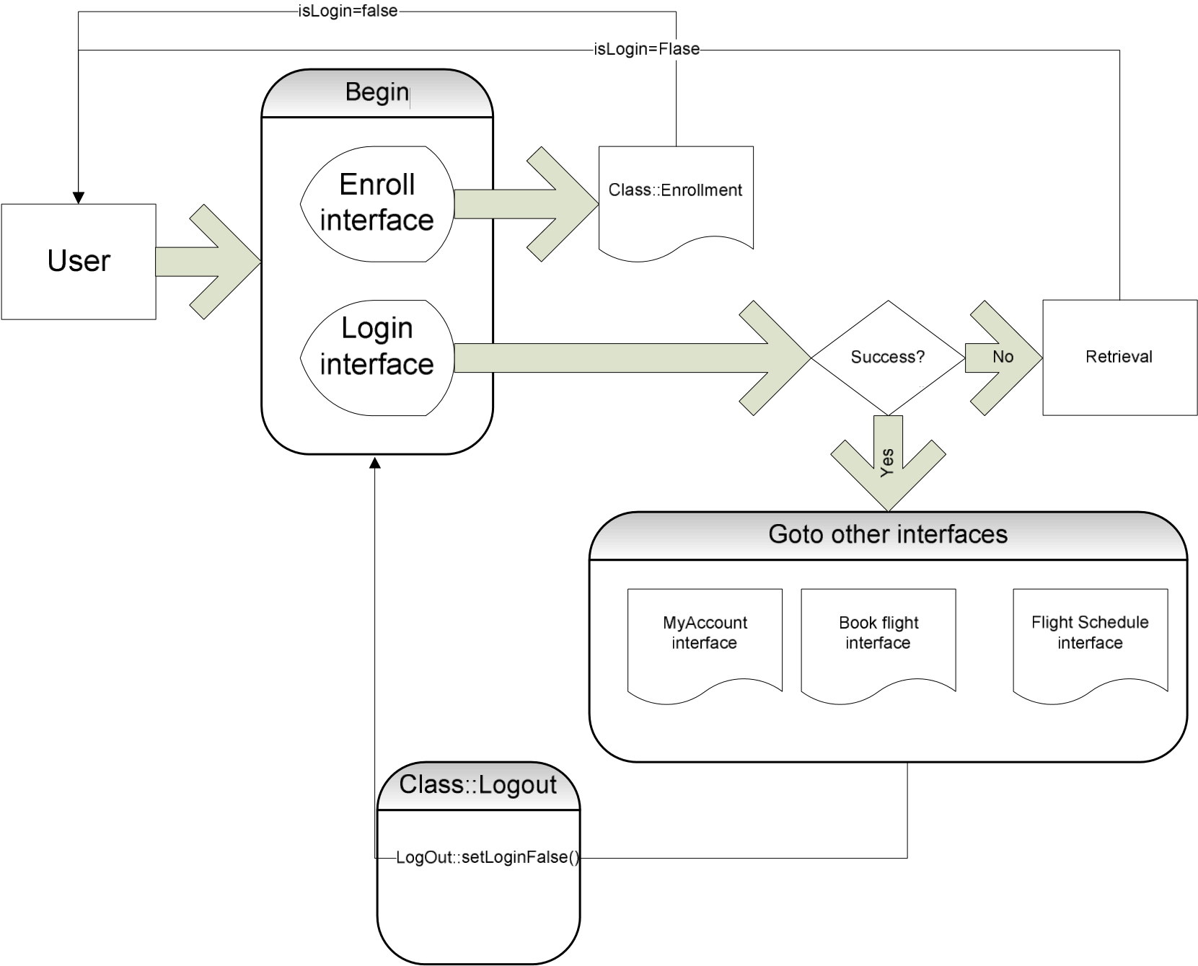

#### Enrollment

**Description and Priority:** This function allows unregistered user to enroll and to create a new account with the website. In order to create a new account, the user has to provide required information such as first name, last name, email address and password. Other optional information, such as phone number, credit card information and mailing address, can be provided during the registration process.

The system checks if all required data are provided and then will prompt the user to enter additional information, if required. After all required information is provided, the system auto-generates a unique frequent flyer number that the user must use as username for future authentications. The system shall auto-generate this number in less than five seconds.

**Inputs:** Required: First name, last name, email address and frequent flyer number

Optional: phone number, credit card information and mailing address.

|  |  |  |
| --- | --- | --- |
|  |  |  |
| **Source:** |  | All data except the frequent flyer number are inputs from the user. The frequent flyer number is from the system store. |
| **Outputs:** |  | Frequent Flyer Number |
| **Destination:** |  | The changes are committed on the completion of the  “enrollment” function to account information. All information also displays to the user via the screen. |
| **Pre-Conditions:** |  | The user must not have an existing account with the website. |
| **Post-Conditions:** |  | A user account is created and the user is able to access all functionalities provided by the function “My Account |
| **Side-Effects:** |  | None |

**Stimulus-Response:**

|  |  |
| --- | --- |
| **User Action** | **System Application** |
|  | 1. The system shows a list of required data that must be provided by the user in order to create a new  account |
| 2. The user provides information such as first name, last name, address, email address, credit card information and password by filling fields. Some data are optional, while others are required | 3. The system checks if all required information have been provided by the user. If a required data is missing, the system prompts the user to provide the specific data in order to process the account creation. |
|  | 4. When every required data is provided, the system creates an account and auto-generates a unique flyer number that must be used as a username for future authentication. The system also sends the user account information, including the flyer number, to the email address provided by the user during |
|  | the account creation process. |

|  |  |
| --- | --- |
| **Book Flights** |  |
| **Description and Priority:** | The user can use the *Book Flights* function to purchase seats for an airplane flight. The system shall present the user with information on all current flights. The user may then select a pair (departure and return) of flights on which to purchase seats. The user can indicate the number of seats and placement of such. Finally, the system shall guide the user completely through the checkout process. |
| **Inputs:** | User information – the user must already be logged in. |
| **Source:** | Inputs are from the user except flight information, which is retrieved from the system. |
| **Output:** | The purchased seats are tied to the user’s account, so he/she can reserve seats later. |
| **Destination:** | The booked flights will be stored in the user’s account information when the user finishes payment. The flight information shall also display on the screen. |
| **Pre-Conditions:** | The user must have an account with the website and must be logged in. |
| **Post-Conditions:** | Completion of this function guarantees that the user has seats on a specific flight. However, if the user wants particular seats, he/she must also complete the reserve seats function. Any successfully-booked flight from this function is assumed to have completed payment already. |
| **Side-Effects:** | User’s account is charged. Flight is associated with user’s account. |

**Stimulus/Response:**

|  |  |  |
| --- | --- | --- |
| **User Action** |  | **System Application** |
|  | 1. | The systems checks to see if the user is logged in, if not then the systems require the user to login. The system shows the user a list of their already booked flights and the available seats for those flights. |
| 2. The user selects individual seats from a list of pre-booked flights. The | 3. | The system checks if the selected seats are still available. If they are |
| seats are chosen in pairs so that the users selects individual seats for the departing and returning flights. | available then the seats are temporarily unavailable to other users to allow the user to confirm their selection. The seats and confirmation selection screen are displayed | |
| 4. The user confirms the seat selections on the screen. | 5. Once confirmed, the seats are removed from available seats and are applied to the user account. The user is shown a final confirmation screen which displays selected seats and account information. | |

**Activity Diagram:**

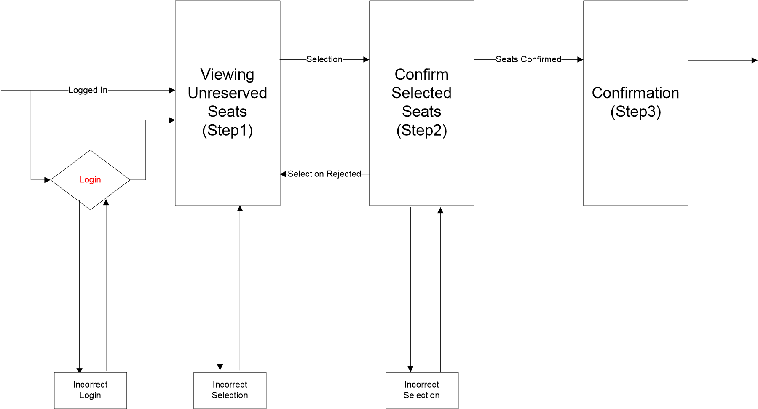

#### Reserve Seats

**Description and Priority:** The user can use the *Reserve Seat* function to reserve seats for

an airplane flight. The seats to be reserved are initially found through the user’s previous bookings. These bookings were previously completed through the *Book Flight* function (SEE 2.2.3).

The system shall display available seats for the departing and returning flights booked by the user. The user selects seats from each flight, where the number of selected seats from each flight is the number that the user booked on that particular flight. Once the flight seats are selected, the user confirms the seat selection.

|  |  |  |
| --- | --- | --- |
|  |  |  |
| **Inputs:** |  | User information used to determine previously booked flights. Selected seats will be reserved by user. |
| **Source:** |  | Inputs are from the user except flight information, which is retrieved by the system. |
| **Outputs:** |  | Selected Seats |
| **Destination:** |  | The changes are committed on completion of the *Reserve Seats* function to the user’s account information. The selected seats are also displayed to the screen. |
| **Pre-Conditions:** |  | The user must have an account with the website and must be logged in. The user must also have previously booked flights without seats reserved, either by user or system. |
| **Post-Conditions:** |  | All selections of seats must be applied to the user’s account. |
| **Side-Effects:** |  | The selected seats are no longer available to any other customer. |

**Stimulus/Response:**

|  |  |
| --- | --- |
| **User Action** | **System Application** |
|  | 1.The systems checks to see if the user is logged in, if not then the system requires the user to login. The system shows the user a list of all flights with open seats that match their requirements. |
| 2.The user selects a flight or a pair of flights (round-trip) that they wish to book. They choose a number of seats they wish to book. | 3.The system checks if the selected flight(s) has their desired number of seats still available. If they are, the system indicates to the user that their flight is in the process of being booked and they must now complete payment. If there aren't enough seats, the system notifies the user which flights were full, and returns the user to the beginning of the function. |
| 4.The user fills out payment information (either credit card or reward number) | 5.If payment is successfully confirmed, the flight is updated with the new |
|  | number of open seats, and the user's account is updated with the reserved flight information. The user is shown a final confirmation screen, which displays flight and account information. |

#### Flight Status

|  |  |  |  |
| --- | --- | --- | --- |
| **Description & Priority:** | | | This section shall allow the user – whether enrolled or not – to view flight information that matches input criteria. The user will provide:   1. A flight number and Date   OR   1. Departing/Arriving Cities and Date.   The system will display matching flight information including the following fields:   * Flight Number o Departure City o Arrival City * Status (one of the following)   + In Flight   + At the Gate   + Delayed   + On Time |
|  |  |  |
| **Inputs:** |  |  | Departing city, Destination city, Departure date/time |
| **Source:** |  |  | All inputs are provided by the user. |
| **Outputs:** |  |  | Flight information including Flight Number, Departure City, Arrival City, and Flight Status. |
| **Destination:** | |  | All outputs should display on the screen. |
| **Pre-Conditions:** | |  | None. |
| **Post-Conditions:** | |  | User has flight status for any matching flight. |
| **Side-Effects:**      **Flight Schedule** | |  | None |
| **Description & Priority:** | | | This section of the system shall allow a user to query flight schedules based upon simple input criteria. The user will provide departure and arrival cities, and a departure/return date. If any flights match the criteria, the system will display the following information: |

o Flight Number o Departing City & Date/Time o Arriving City & Date/Time o Number of Available Seats

|  |  |  |  |
| --- | --- | --- | --- |
|  |  |  | The system shall define a “matching” flight as one that uses the departure/arrival cities at a flight time greater or equal to the time provided by the user. Otherwise, the system shall alert the user that no matching flights can be found. |
| **Inputs:** |  |  | Departing City, Destination City, Departure Date/Time |
| **Source:** |  |  | All inputs provided by user. |
| **Outputs:** |  |  | Flight Information including Flight Number, Departing City & Date/Time, Arriving City and Date/Time, Number of Available Seats. |
| **Destination**: | |  | All output should display to the screen. |
| **Pre-Conditions**: | |  | None |
| **Post-Conditions**: | |  | User has flight information for any matching flight. |

**Activity Diagram:**

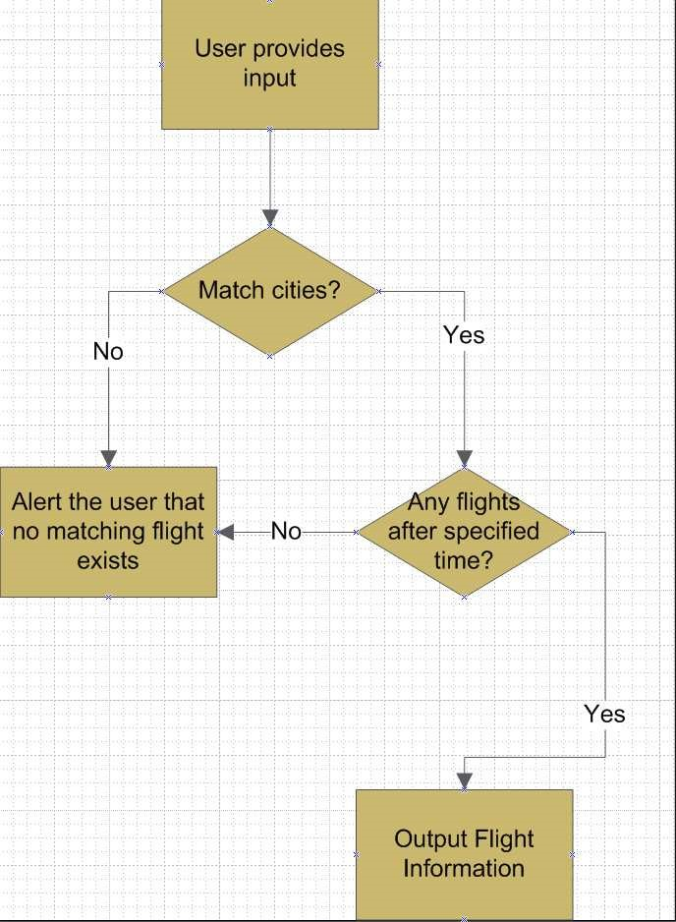

#### My Account

|  |  |
| --- | --- |
| **Description & Priority:** | This section gives the user the power to view, save, edit or delete the information stored in his/her account. The user can check his/her accumulated points, look at the status of a flight that was booked, cancel a flight that was already booked (optional) and change his/her address, phone number, email or password. This feature is not available for non-registered user. |
| **Inputs:** | Account changes, if any, made by the user. Account changes include updates on first name, last name, email address, mailing address, password or phone numbers. |
| **Source:** | All data are inputs from user. |
| **Output:** | None. |
| **Destination:** | The changes are committed on completion of the *My Account* function to account information. |
| **Pre-Conditions:** | The user must have an account with the website and must be logged in prior to access his/her account. |
| **Post-Conditions:**      **Account Log out** | All changes submitted by the user are applied to the user account on completion of the function. |
| **Description & Priority:** | The *Logout* section provides a way for the user to securely log out of the system. This process will save all user operations when he/she exits the system. If a user wishes to continue accessing the website, he/she must log-in again to access user features. |
| **Inputs:** | None. |
| **Source:** | N/A |
| **Outputs:** | Notification that the user is logged out. |
| **Destination:** | User is notified by display to screen. |
| **Pre-Conditions:** | User is logged in to the system. |
| **Post-Conditions:** | User is logged out of the system. |
| **Side-Effects:** | The system clears the session state for the user once logout is complete. |

## External Interface Requirements

### User Interfaces

A *Help* link will appear on every screen that describes the function of each page to the user. The implementation should be written so that blind users can still interact with the system (using a screen reader.)

### Communications Interfaces

The system must utilize the standard Hyper Text Transfer Protocol (HTTP) to ensure maximum inter-browser compatibility. The client accesses the system through a web browser.

## Other Nonfunctional Requirements

### Performance Requirements

* The Airline Website shall have capabilities to accept 500 connections. For each session, system shall guarantee the connection time 5 minutes from last input, after which the connection will be deemed expired. A close operation will be performed when expired. This design is to satisfy each user’s usability and connection quality.

* The system shall send out verification request immediately (within 100ms) after the it receives a user submitted form.

* The system shall update all flight status information every 5 minutes.

### Security Requirements

* Passwords must be a minimum of eight characters and must contain one to seven digits.

* Email addresses should be verified before the system grants user access. This verification shall be exercised by sending the prospective user a confirmation email after enrollment. This email must contain information specific to completing the enrollment process.

* All exchanges from client to server involving private data shall occur using the highest available level of secure connection (e.g., https).

### Software Quality Attributes

**Usability:**

The airline website design shall allow deployment on both Windows and UNIX (Linux) servers.

**Robustness:**

The system design shall include recovery scenarios allowing the ability to restore a state no older than one business day old.